**TEAM “Jodi-Picoult”**

*Project Documentation*

Table of Contents

1. **Team Members** 2
2. **Project Description** 2
   1. *Structure of the project* 3
   2. *Class diagram* 3
3. **Git Repository** 4
4. **Additional Information** 4



1. **Team Members**

*All six members of team “Jodi-Picoult” are listed in the table below (in alphabetical order).*

|  |  |
| --- | --- |
| *Name* | *Student System Username* |
| Geno Genov | G.Genov |
| Georgi Mitev | g_m_mitev |
| Krasimir Zarev | KrasiBenassi |
| Krum Bagashev | skloser |
| Simeon Tzvetkov | STzvetkov |
| Teodor Karabeliov | teodor_k |

1. **Project Description**

Our team has decided to create a game dedicated to the most adventurous, romantic, dangerous and … profitable profession in the history, i.e. – the piracy. But not the one related to torrents, keygens, zamunda.net, etc. It is the original, bloodthirsty, with pistols in both hands and sword in their jaws, a bit ragged, but bold and brave gentlemen of fortune that we want to impersonate our player. Or at least their captain. Or maybe just the ship? Every big undertaking has its modest beginning.

The player is given control over a pirate ship which he/she could move over the play field – a part of the great ocean with islands, settlements … and of course enemy ships (see the attached screenshot below). When the player-controlled ship collides with the most unlucky sea vessel this day in the open sea, a battle screen is opened where a gunfight between the two ships takes part. When the Player wins the battle (any doubts about this ending?), he exits the battle mode and continue to roam the seas in search for new prey.

The RPG side of the game includes various upgrades of the ship and items collected after successful battles or (if lucky enough) from ship wreckages found after severe storms. Those upgrades (of hull, weaponry, etc.) affect the battles, the ship speed, etc.

The game has an economic element as well. All the civilian settlements on the shores have some specialization: trading centers produce either trading goods, grains or fruits, fishing villages produce … fish (what a surprise!), oil platforms prod… ops! this is for a future release ☺

Global map:

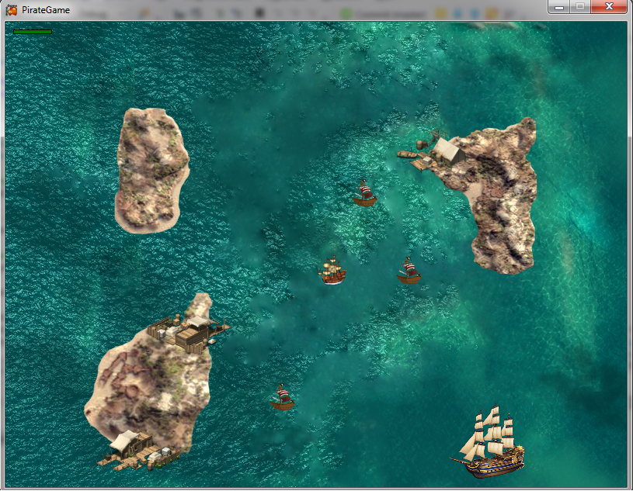

Battle mode:

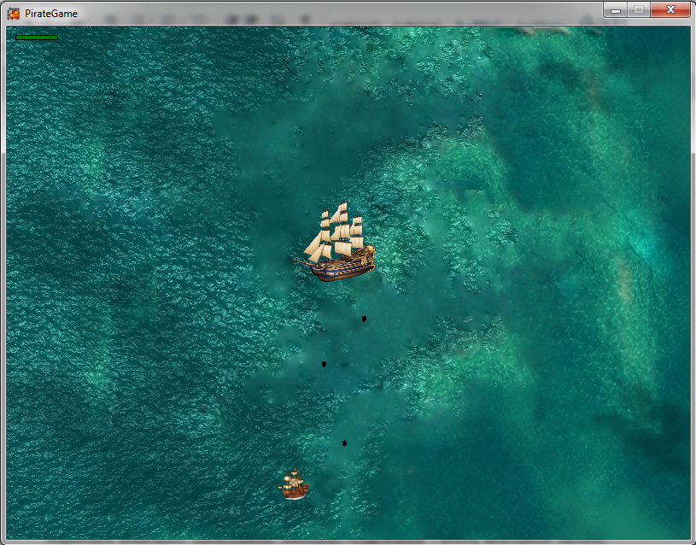

* 1. Structure of the project

The game’s design follows the main concepts of the object-oriented programming. There is a corresponding class for each object from the real world: ship, upgrade, settlement (all kinds of), projectile, etc. Classes are organized hierarchical by proper using of inheritance (see the class diagram below). There are interfaces to define a given “ability” which a given class can implement (examples: IDestroyable, IMovable, IUpgradable – pretty descriptive names).

The framework Monogame was used for implementing the graphics, time management and other important features of the game.

Class diagram

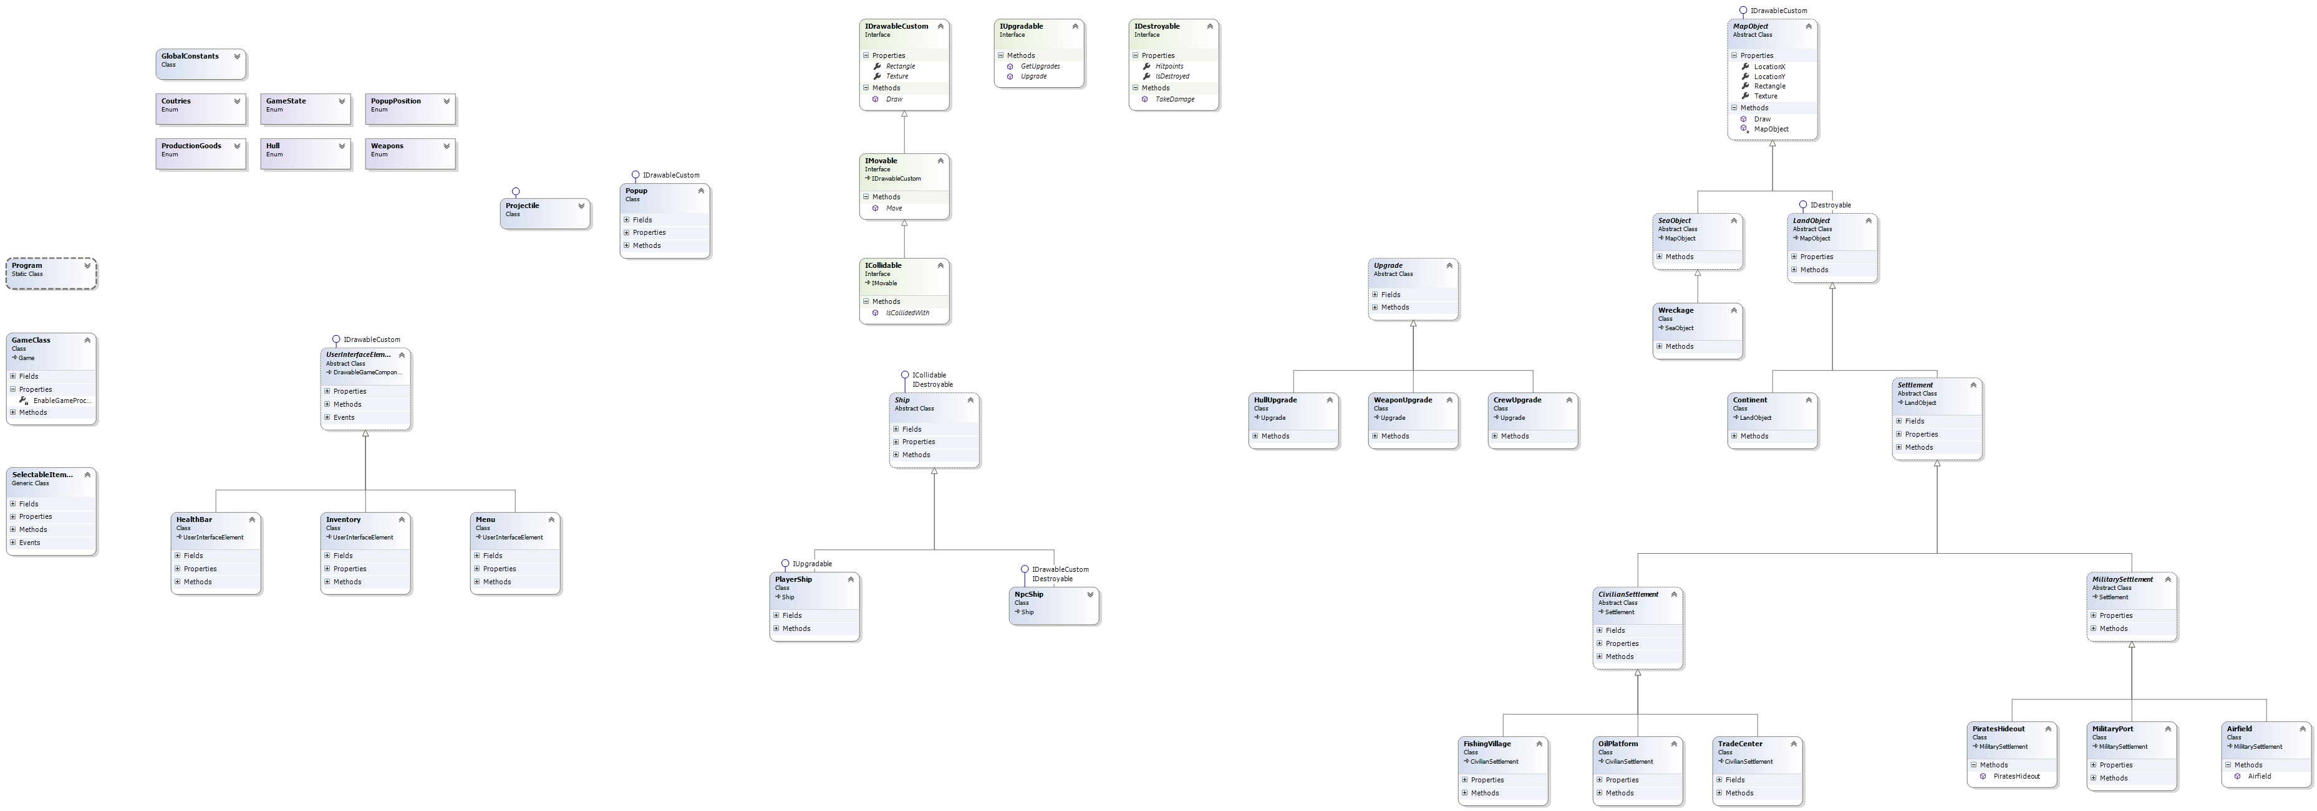

1. **Git Repository**

*This is the URL of our Git Hub repository (****Project “Jodi-Picoult”****):*

<https://github.com/STzvetkov/Jodi-Picoult>